**University of Management and Technology (UNIMTECH)**  
**Group Project: Collaborative Development of a Financial Calculator Using Git and GitHub**

Group: A

**# Step-by-Step Documentation for the Payment Calculation Program**

**1. Overview**

This Python program allows users to calculate:

* Loan Payment
* Compound Interest
* Savings Growth

The user is prompted to choose the type of calculation, after which the corresponding function is executed.

**2. Program Flow**

1. **User Input:** The program first asks the user to choose a payment type:

" 1. LOANPAYMENT"

" 2. COMPOUNDINTEREST"

"3. SAVINGSGROWTH"

1. **Decision Making:** Based on the user’s input, the program calls the respective function:
   * loan_pay () for loan payments.
   * compound_interest () for compound interest.
   * savings_growth () for savings growth.
2. **Computation:** The program collects user input, performs calculations, and outputs the result.
3. **Error Handling:** If an invalid option is entered, the program prompts the user to select a valid payment type.

**3. Function Breakdown**

**3.1 Loan Payment Calculation (loanCalculation())**

* **Inputs:**
  + Principal amount
  + Annual interest rate
  + Loan term in years
* **Processing:**
  + Converts the annual interest rate to a monthly rate.
* Uses the loan payment formula: $\frac{P×r×{\left(1+r\right)}^{n}}{{\left(1+r\right)}^{n}-1}$
* Where:
* M= Monthly payment
* P= Principal loan amount
* r= Monthly interest rate (Annual rate / 12 / 100)
* n= Total number of months (Years × 12)

Output**:**

* Displays the calculated monthly payment.

**3.2 Compound Interest Calculation (compoundInterestCal())**

* **Inputs:**
  + Principal amount
  + Annual interest rate
  + Years invested
  + Number of times the interest is compounded per year
* **Processing:**
  + Converts the annual interest rate into a decimal form.
* Formula: $A=Px{\left(\begin{aligned}1+\frac{r}{n} \\ \end{aligned}\right)}^{nx^{t}}$

Where:

A= Future value of the investment

P= Principal amount

r= Annual interest rate (in decimal form)

n= Number of times interest is compounded per year

t= Time in years

* **Output:**
* Displays the future value of the investment.

**3.3 Savings Growth Calculation (SavingsGrowth())**

* **Inputs:**
  + Initial savings
  + Monthly contribution
  + Annual interest rate
  + Number of times interest is compounded per year
  + Number of years
* **Processing:**
  + Converts annual interest rate to decimal form.

Formula: $FV=P+{\left(1+r\right)}^{t}+\frac{M×\left[{\left(1+1\right)}_{-}^{t}1\right]}{r}$

Where:

* FV= Future value of savings
* P= Initial savings
* M= Monthly contribution
* r= Monthly interest rate (Annual rate / 12 / 100)
* t= Number of months

**Output:**

* Displays the future savings amount.

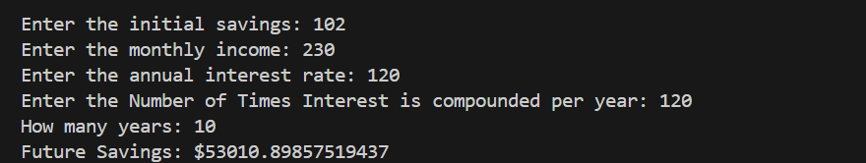

  4. Error Handling

If an invalid payment type is entered, the program displays:

Please choose between one of the following payment types:

LOANPAYMENT

COMPOUNDINTEREST

SAVINGSGROWTH

Below is a summery of the flowchart

